1.

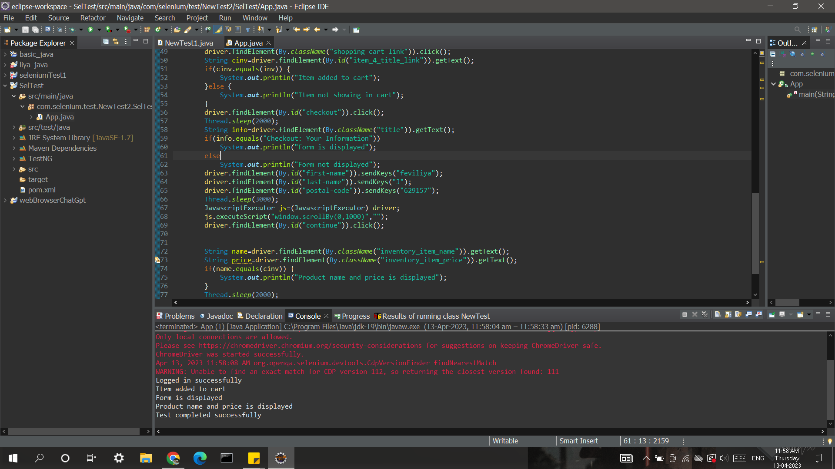

package com.selenium.test.NewTest2.SelTest;

import java.util.List;

import org.openqa.selenium.By;

import org.openqa.selenium.JavascriptExecutor;

import org.openqa.selenium.Keys;

import org.openqa.selenium.WebDriver;

import org.openqa.selenium.WebElement;

import org.openqa.selenium.chrome.ChromeDriver;

import org.openqa.selenium.chrome.ChromeOptions;

import org.openqa.selenium.support.ui.Select;

import org.testng.Assert;

import dev.failsafe.internal.util.Assert.*;

import io.github.bonigarcia.wdm.WebDriverManager;

public class App

{

public static void main( String[] args ) throws InterruptedException

{

WebDriverManager.chromedriver().setup();

ChromeOptions co = new ChromeOptions();

co.addArguments("--remote-allow-origins=*");

WebDriver driver=new ChromeDriver(co);

driver.get("https://www.saucedemo.com/");

driver.manage().window().maximize();

String t="Swag Labs";

String t1=driver.getTitle();

Assert.assertEquals(t, t1);

driver.findElement(By.id("user-name")).sendKeys("standard_user");

driver.findElement(By.id("password")).sendKeys("secret_sauce");

driver.findElement(By.id("password")).sendKeys(Keys.ENTER);

Thread.sleep(2000);

if(driver.getCurrentUrl().equals("https://www.saucedemo.com/inventory.html"))

System.out.println("Logged in successfully");

else {

System.out.println("Failed to login");

driver.close();

}

Thread.sleep(2000);

String inv=driver.findElement(By.id("item_4_title_link")).getText();

driver.findElement(By.id("add-to-cart-sauce-labs-backpack")).click();

driver.findElement(By.className("shopping_cart_link")).click();

String cinv=driver.findElement(By.id("item_4_title_link")).getText();

if(cinv.equals(inv)) {

System.out.println("Item added to cart");

}else {

System.out.println("Item not showing in cart");

}

driver.findElement(By.id("checkout")).click();

Thread.sleep(2000);

String info=driver.findElement(By.className("title")).getText();

if(info.equals("Checkout: Your Information"))

System.out.println("Form is displayed");

else

System.out.println("Form not displayed");

driver.findElement(By.id("first-name")).sendKeys("feviliya");

driver.findElement(By.id("last-name")).sendKeys("J");

driver.findElement(By.id("postal-code")).sendKeys("629157");

Thread.sleep(3000);

JavascriptExecutor js=(JavascriptExecutor) driver;

js.executeScript("window.scrollBy(0,1000)","");

driver.findElement(By.id("continue")).click();

String name=driver.findElement(By.className("inventory_item_name")).getText();

String price=driver.findElement(By.className("inventory_item_price")).getText();

if(name.equals(cinv)) {

System.out.println("Product name and price is displayed");

}

Thread.sleep(2000);

Assert.assertEquals("https://www.saucedemo.com/checkout-step-two.html",driver.getCurrentUrl());

System.out.println("Test completed successfully");

driver.quit();

}

}

2. 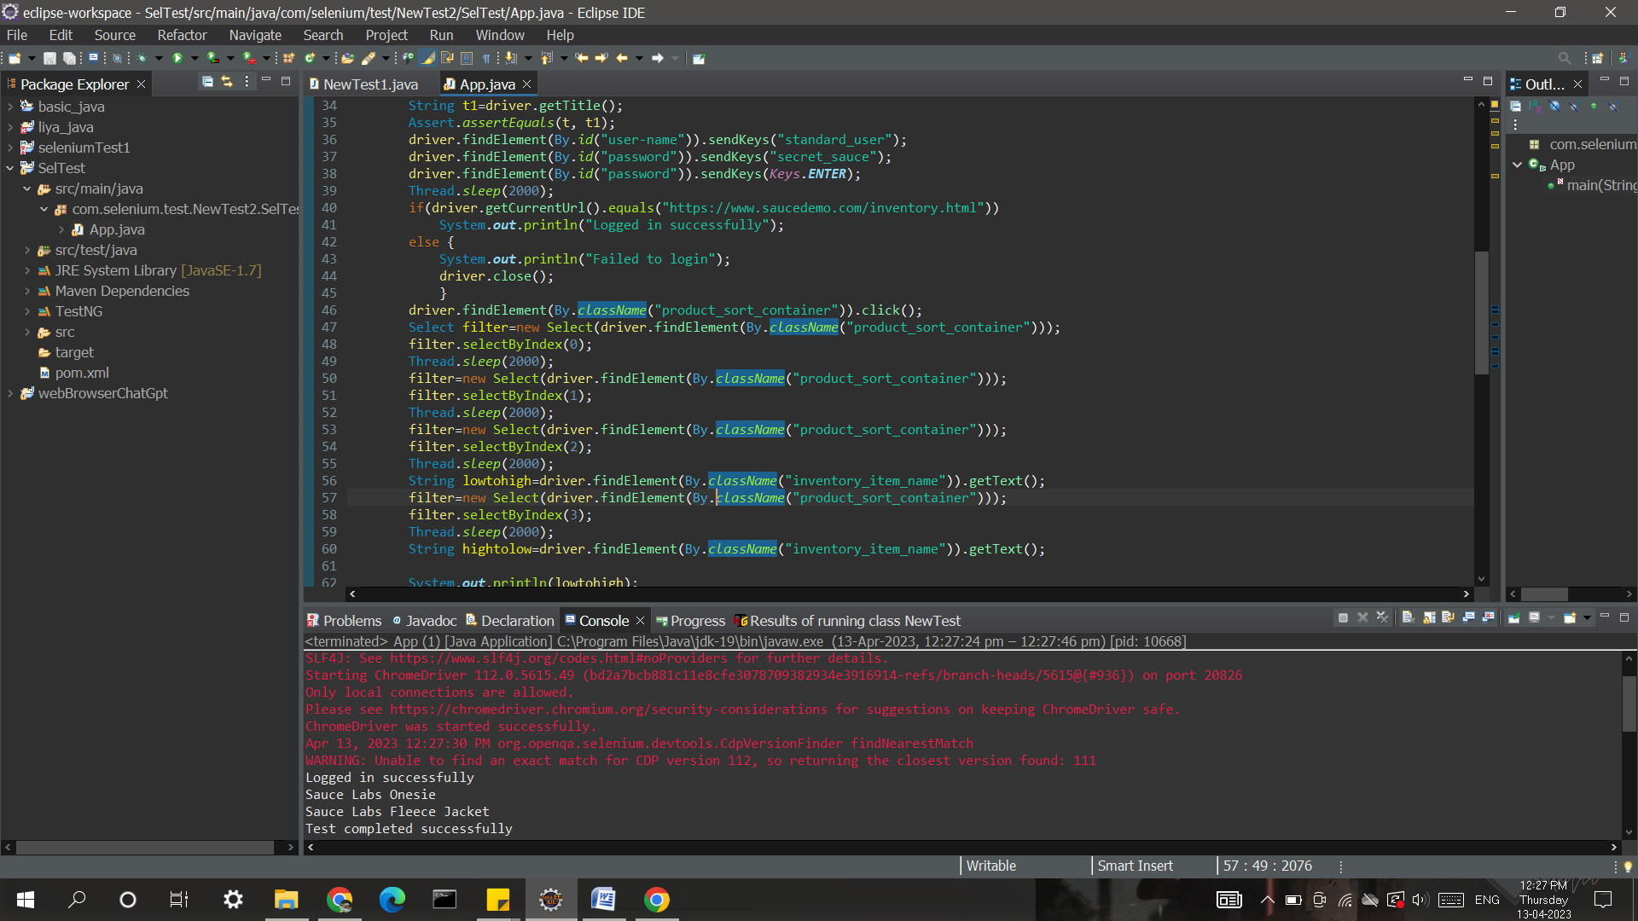

package com.selenium.test.NewTest2.SelTest;

import java.util.List;

import org.openqa.selenium.By;

import org.openqa.selenium.JavascriptExecutor;

import org.openqa.selenium.Keys;

import org.openqa.selenium.WebDriver;

import org.openqa.selenium.WebElement;

import org.openqa.selenium.chrome.ChromeDriver;

import org.openqa.selenium.chrome.ChromeOptions;

import org.openqa.selenium.support.ui.Select;

import org.testng.Assert;

import dev.failsafe.internal.util.Assert.*;

import io.github.bonigarcia.wdm.WebDriverManager;

/**

* Hello world!

*

*/

public class App

{

public static void main( String[] args ) throws InterruptedException

{

WebDriverManager.chromedriver().setup();

WebDriver driver;

ChromeOptions co = new ChromeOptions();

co.addArguments("--remote-allow-origins=*");

driver=new ChromeDriver(co);

driver.get("https://www.saucedemo.com/");

driver.manage().window().maximize();

String t="Swag Labs";

String t1=driver.getTitle();

Assert.assertEquals(t, t1);

driver.findElement(By.id("user-name")).sendKeys("standard_user");

driver.findElement(By.id("password")).sendKeys("secret_sauce");

driver.findElement(By.id("password")).sendKeys(Keys.ENTER);

Thread.sleep(2000);

if(driver.getCurrentUrl().equals("https://www.saucedemo.com/inventory.html"))

System.out.println("Logged in successfully");

else {

System.out.println("Failed to login");

driver.close();

}

driver.findElement(By.className("product_sort_container")).click();

Select filter=new Select(driver.findElement(By.className("product_sort_container")));

filter.selectByIndex(0);

Thread.sleep(2000);

filter=new Select(driver.findElement(By.className("product_sort_container")));

filter.selectByIndex(1);

Thread.sleep(2000);

filter=new Select(driver.findElement(By.className("product_sort_container")));

filter.selectByIndex(2);

Thread.sleep(2000);

String lowtohigh=driver.findElement(By.className("inventory_item_name")).getText();

filter=new Select(driver.findElement(By.className("product_sort_container")));

filter.selectByIndex(3);

Thread.sleep(2000);

String hightolow=driver.findElement(By.className("inventory_item_name")).getText();

System.out.println(lowtohigh);

System.out.println(hightolow);

System.out.println("Test completed successfully");

driver.quit();

}

}